**Smartflow Dilution Recommendation**

Many medications need to be diluted either to a standard preassigned dilution or a custom one so there are two areas I think this should be added.

Firstly if you had an optional box in the settings/parameters area when you first created a medication the doctor could preassign a concentration to dilute the medication to in this set up area. This would have to be optional but if they entered it here it should carry through onto the next area (screenshot 2).

The would need to have the option to leave it blank however because many medications do not need to be diluted or the dilution concentration is variable.

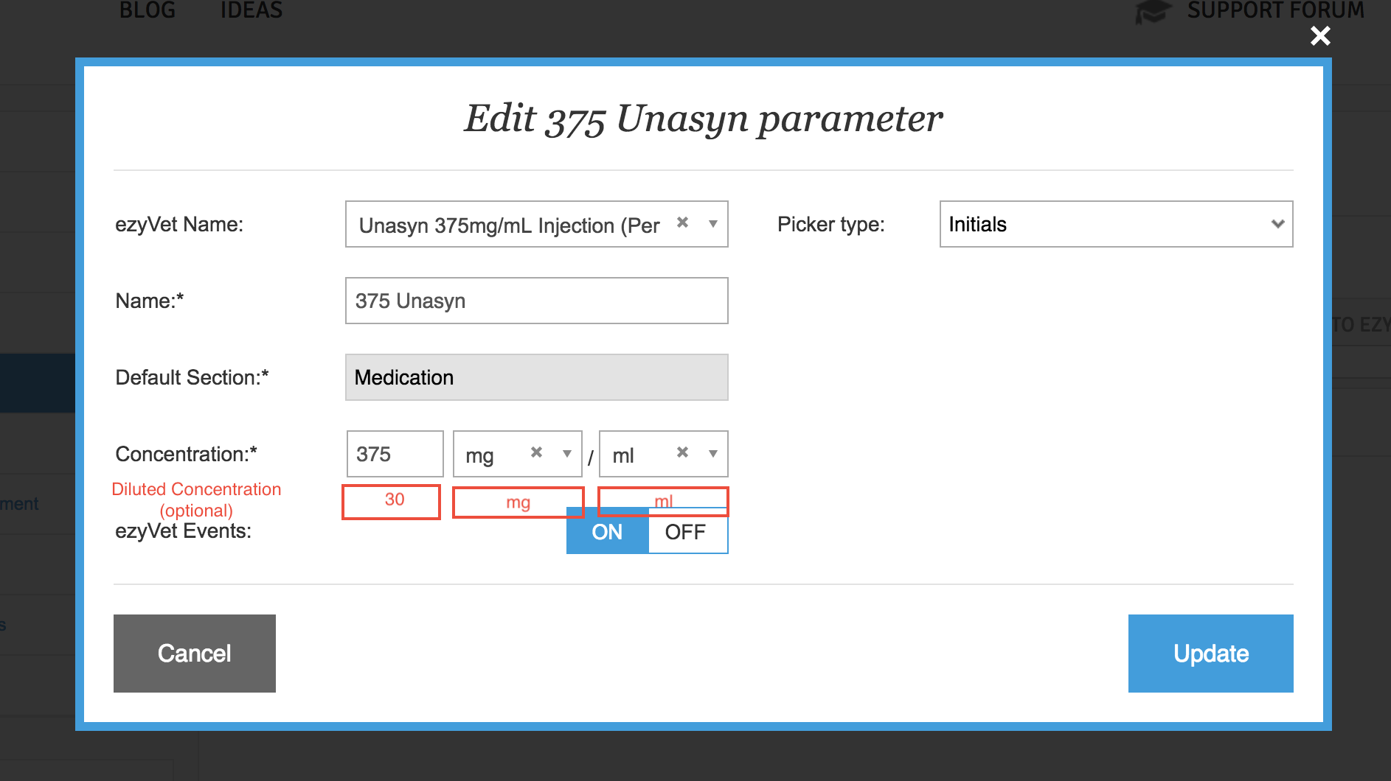

The second area that would need the addition would be when signing a patient up for that medication on the treatment sheet itself. The pop up box to put the dosage in should also have this diluted concentration box. If in the settings the medication was set up with a preassigned concentration like in the first screenshot then this concentration should auto fill into this field. (see e.g. below with 30mg/ml filling in).

If the field was left blank in the parameters set up this should be blank and allow someone to enter a dilution concentration for themselves. The drop down options are the same as for concentration (mg, mcg, ml, etc).

If they DO NOT enter a dilution concentration then the total dose in mg and ml should be based off the concentration at the top of the screen. (375mg/ml) as it is currently. If they DO enter a dilution concentration like in this example then the dosage and total ml should be calculated based on the diluted concentration (30mg/ml in this example).

This would mean that the total mg is the same in both examples but the volume of ml is different depending on whether the medication is undiluted or diluted.

